**Question 1 Code:**

.data

Message: .asciiz "\n Hello, World \n"

.text

li $v0,4

la $a0, Message

syscall

li $v0, 10

syscall

**Question 1 Screenshots with Output:**

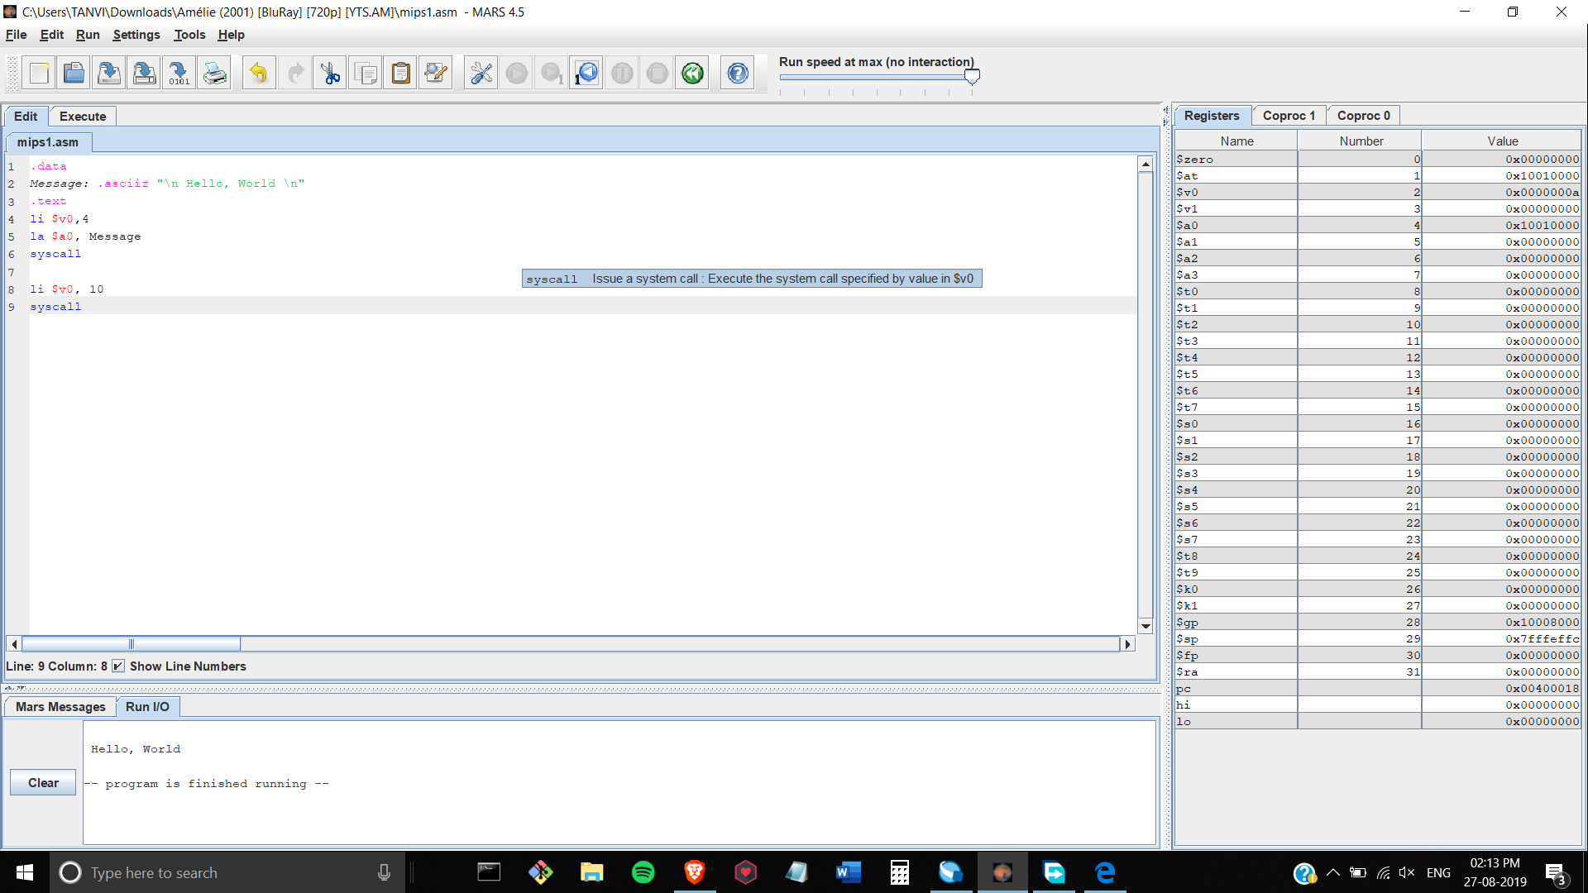

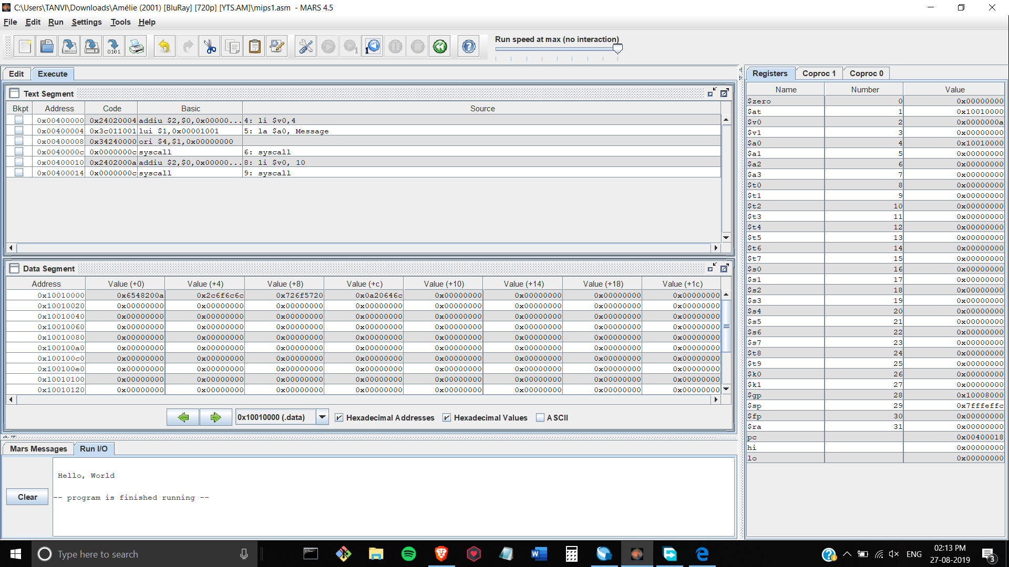

**Question 2 Code:**

.data

sum: .asciiz "\nSum:"

.text

li $t0 15

li $t1 12

add $t2, $t1, $t0

li $v0, 4

la $a0, sum

syscall

li $v0, 1

la $a0, ($t2)

syscall

li $v0, 10

syscall

**Question 2 Screenshots with Output:**

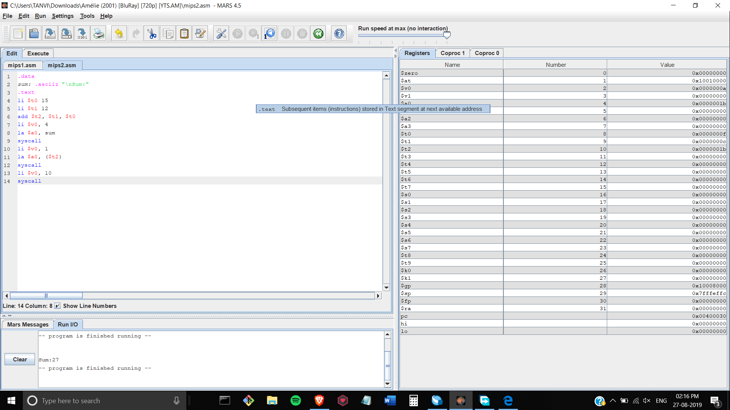

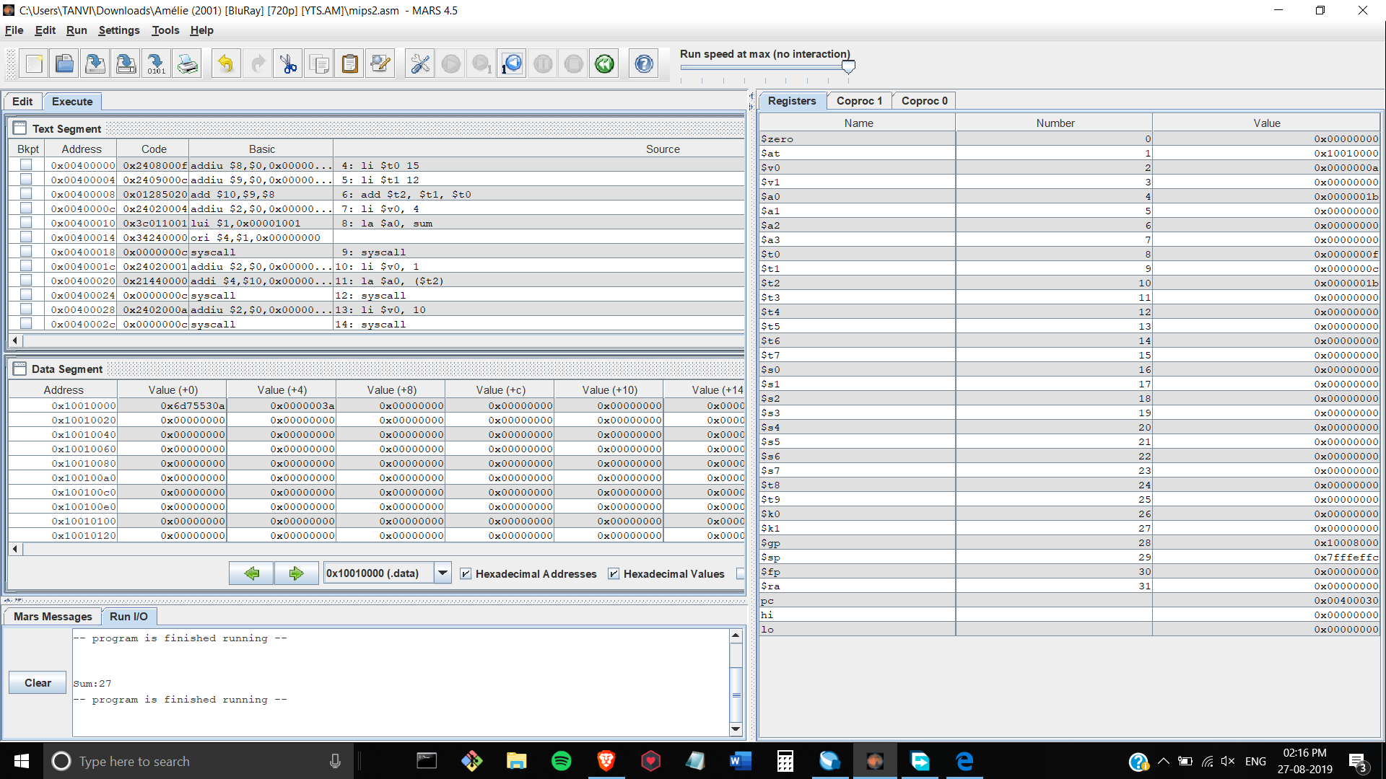

**Question 3 Code:**

.data

ques1: .asciiz "\nResult:"

.text

li $t0,10

li $t1,5

li $t2,2

add $t3,$t0,$t1

sub $t4,$t3,$t2

add $t5,$t4,5

mul $t6,$t5,3

li $v0, 4

la $a0, ques1

syscall

li $v0, 1

la $a0, ($t6)

syscall

li $v0, 10

syscall

**Question 3 Screenshots with Output:**

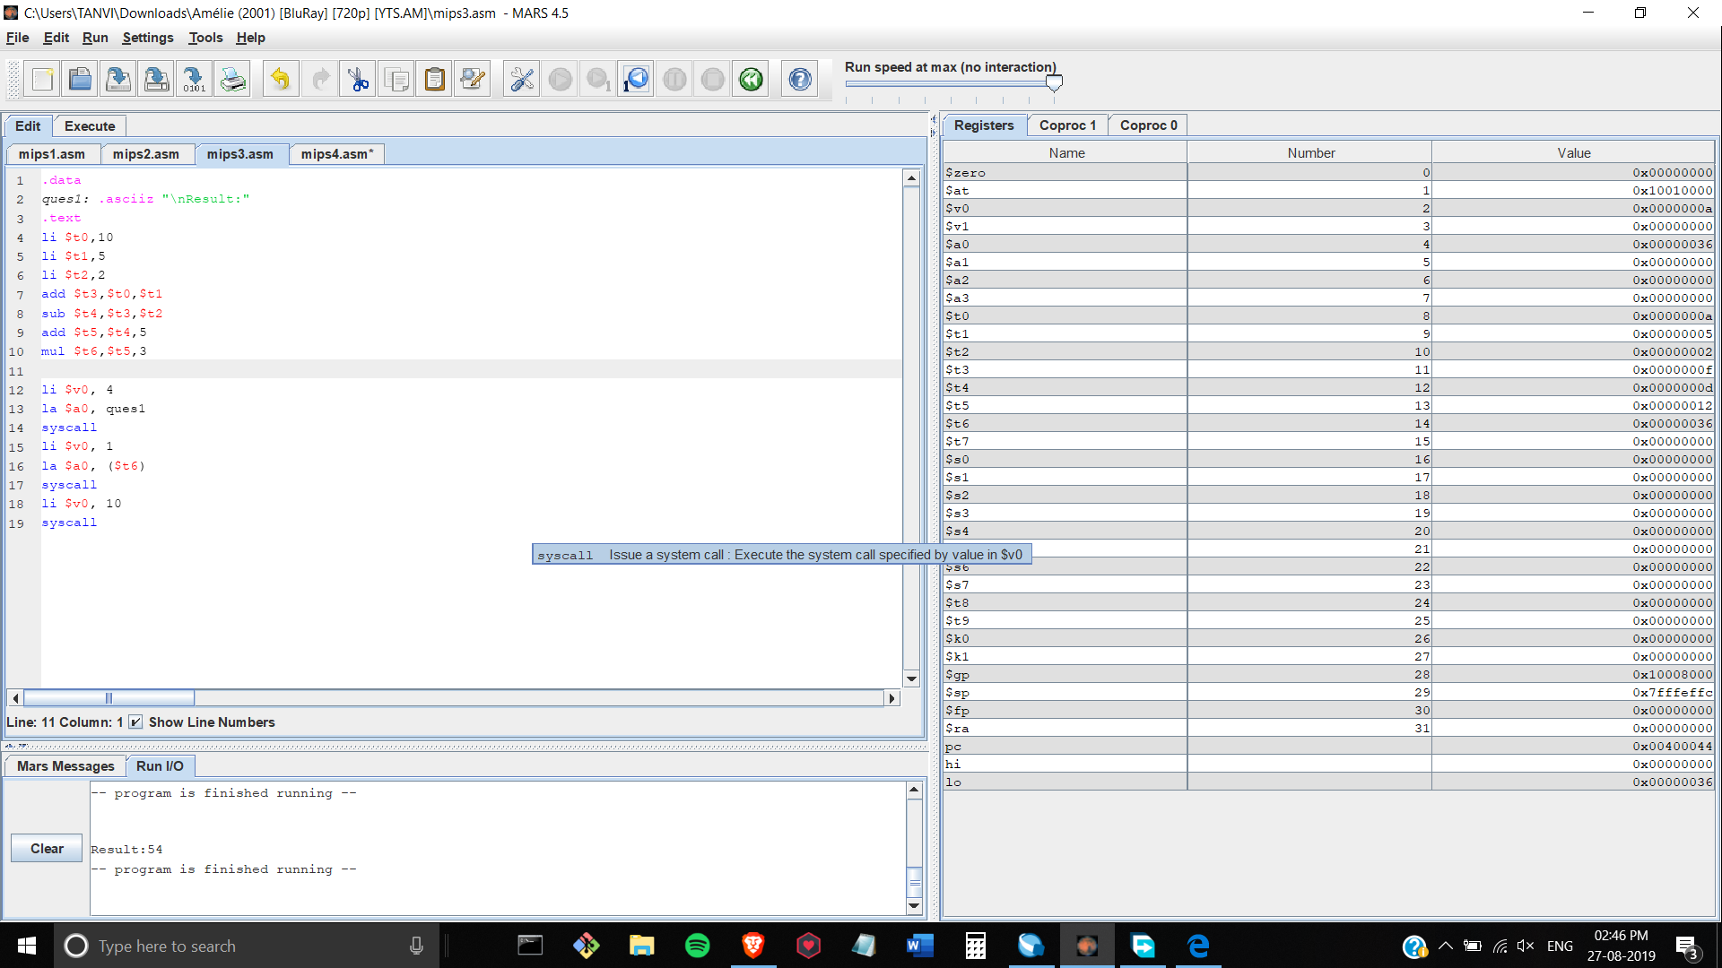

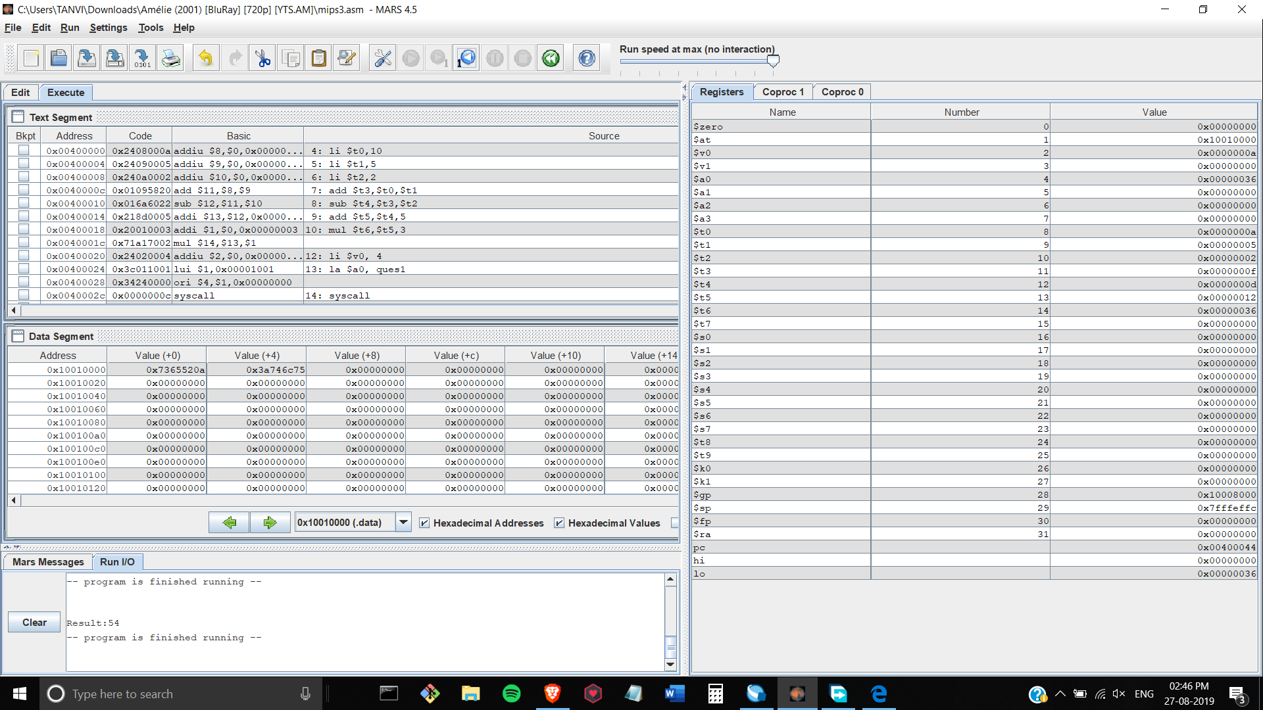

**Question 4 Code (Given on the Board):**

.data

ques: .asciiz "\nResult:"

state1: .asciiz "\nThe value of B is: "

state2: .asciiz "\nThe value of C is: "

state3: .asciiz "\nThe value of D is: "

state4: .asciiz "\nThe value of Z is: "

state5: .asciiz "\nThe value of Y is: "

.text

li $t0,25

li $t1,10

li $t2,15

li $t5,5

li $t6,2

add $t3,$t0,$t1

add $t4,$t3,$t2

add $t7,$t4,$t5

add $t8,$t7,$t6

sub $t9,$t6,$t4

sub $v1,$t9,$t1

li $v0, 4

la $a0, state1

syscall

li $v0, 1

la $a0, ($t0)

syscall

li $v0, 4

la $a0, state2

syscall

li $v0, 1

la $a0, ($t1)

syscall

li $v0, 4

la $a0, state3

syscall

li $v0, 1

la $a0, ($t2)

syscall

li $v0, 4

la $a0, state4

syscall

li $v0, 1

la $a0, ($t5)

syscall

li $v0, 4

la $a0, state5

syscall

li $v0, 1

la $a0, ($t6)

syscall

li $v0, 4

la $a0, ques

syscall

li $v0, 1

la $a0, ($v1)

syscall

li $v0, 10

syscall

**Question 4 Screenshots with Output:**

